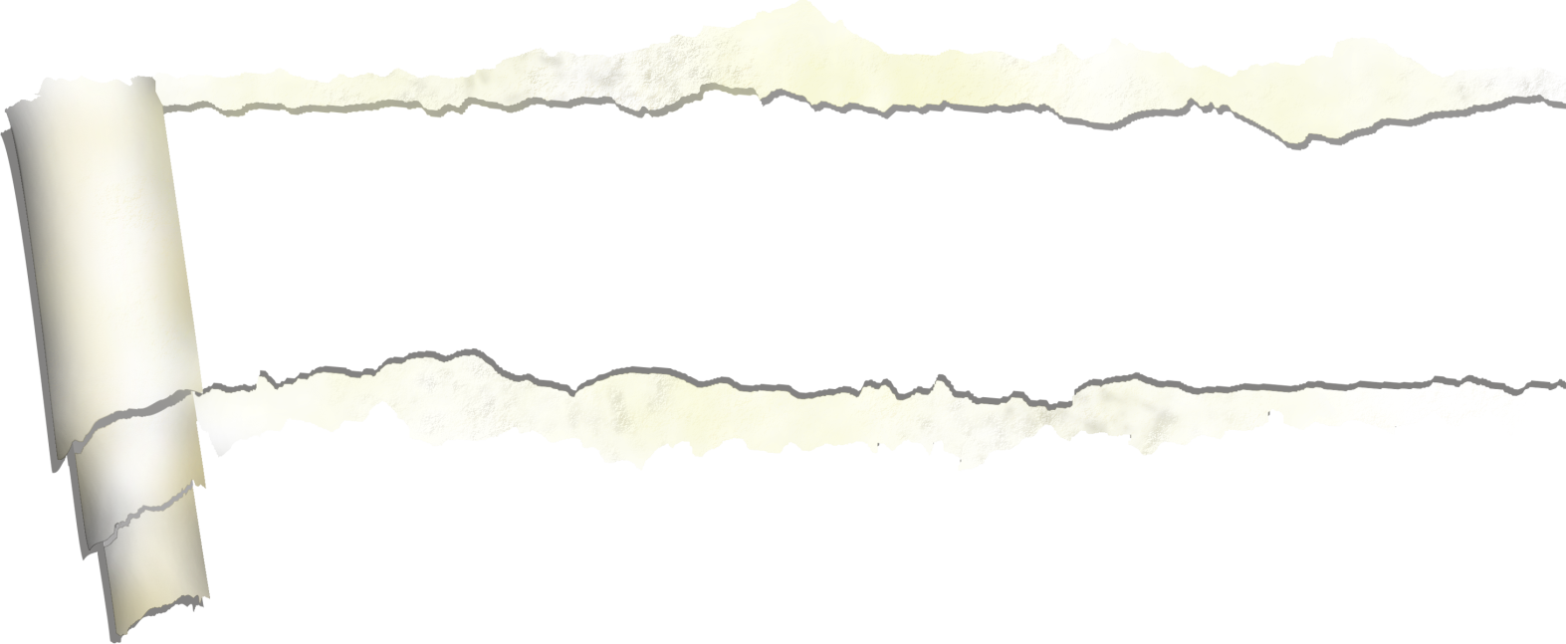

|  |  |  |  |  |  |  |
| --- | --- | --- | --- | --- | --- | --- |
| Lundi | Mardi | Mercredi | Jeudi | Vendredi | Samedi | Dimanche |
|  |  |  | 1 | 2 | 3 | 4 |
| 5 | 6 | 7 | 8 | 9 | 10 | 11 |
| 12 | 13 | 14 | 15 | 16 | 17 | 18 |
| 19 | 20 | 21 | 22 | 23 | 24 | 25 |
| 26 | 27 | 28 | 29 | 30 | 31 |  |

**2024**

**Août**

|  |  |  |  |  |  |  |
| --- | --- | --- | --- | --- | --- | --- |
| Lundi | Mardi | Mercredi | Jeudi | Vendredi | Samedi | Dimanche |
|  |  |  |  |  |  | 1 |
| 2 | 3 | 4 | 5 | 6 | 7 | 8 |
| 9 | 10 | 11 | 12 | 13 | 14 | 15 |
| 16 | 17 | 18 | 19 | 20 | 21 | 22 |
| 23 | 24 | 25 | 26 | 27 | 28 | 29 |
| 30 |  |  |  |  |  |  |

**2013**

**Septembre**





|  |  |  |  |  |  |  |
| --- | --- | --- | --- | --- | --- | --- |
| Lundi | Mardi | Mercredi | Jeudi | Vendredi | Samedi | Dimanche |
|  | 1  Histoire continue | 2  Araignée en bricolage | 3  Mimes | 4  Chaines au pompiers | 5 | 6 |
| 7  Gymnase ballon chasseur | 8  Citrouille articulé | 9  Devinette sur l’Halloween | 10  Histoire d’Halloween | 11  Chapeau au sorcier | 12 | 13 |
| 14  Gymnase 123 soleil | 15  Chasse aux trésors | 16  Le chat noir | 17  Chanson d’Halloween avec geste | 18  PM cap | 19 | 20 |
| 21  Gymnase spaghetti tomate | 22  Peinture de citrouille | 23  Peinture de citrouille | 24  Masque d’Halloween | 25  Pédago | 26 | 27 |
| 28  Gymnase | 29  Murale d’Halloween | 30  Maquillage d’Halloween | 31  Parade de costumes |  |  |  |

**2013**

**Octobre**



|  |  |  |  |  |  |  |
| --- | --- | --- | --- | --- | --- | --- |
| Lundi | Mardi | Mercredi | Jeudi | Vendredi | Samedi | Dimanche |
|  |  |  |  | 1 | 2 | 3 |
| 4 | 5 | 6 | 7 | 8 | 9 | 10 |
| 11 | 12 | 13 | 14 | 15 | 16 | 17 |
| 18 | 19 | 20 | 21 | 22 | 23 | 24 |
| 25 | 26 | 27 | 28 | 29 | 30 |  |

**2013**

**Novembre**



|  |  |  |  |  |  |  |
| --- | --- | --- | --- | --- | --- | --- |
| Lundi | Mardi | Mercredi | Jeudi | Vendredi | Samedi | Dimanche |
|  |  |  |  |  |  | 1 |
| 2 | 3 | 4 | 5 | 6 | 7 | 8 |
| 9 | 10 | 11 | 12 | 13 | 14 | 15 |
| 16 | 17 | 18 | 19 | 20 | 21 | 22 |
| 23 | 24 | 25 | 26 | 27 | 28 | 29 |
| 30 | 31 |  |  |  |  |  |

**2013**

**Décembre**

|  |  |  |  |  |  |  |
| --- | --- | --- | --- | --- | --- | --- |
| Lundi | Mardi | Mercredi | Jeudi | Vendredi | Samedi | Dimanche |
|  |  | 1 | 2 | 3 | 4 | 5 |
| 6 | 7 | 8 | 9 | 10 | 11 | 12 |
| 13 | 14 | 15 | 16 | 17 | 18 | 19 |
| 20 | 21 | 22 | 23 | 24 | 25 | 26 |
| 27 | 28 | 29 | 30 | 31 |  |  |



**2014**

**Janvier**



|  |  |  |  |  |  |  |
| --- | --- | --- | --- | --- | --- | --- |
| Lundi | Mardi | Mercredi | Jeudi | Vendredi | Samedi | Dimanche |
|  |  |  |  |  | 1 | 2 |
| 3 | 4 | 5 | 6 | 7 | 8 | 9 |
| 10 | 11 | 12 | 13 | 14 | 15 | 16 |
| 17 | 18 | 19 | 20 | 21 | 22 | 23 |
| 24 | 25 | 26 | 27 | 28 |  |  |

**2014**

**Février**



|  |  |  |  |  |  |  |
| --- | --- | --- | --- | --- | --- | --- |
| Lundi | Mardi | Mercredi | Jeudi | Vendredi | Samedi | Dimanche |
|  |  |  |  |  | 1 | 2 |
| 3 | 4 | 5 | 6 | 7 | 8 | 9 |
| 10 | 11 | 12 | 13 | 14 | 15 | 16 |
| 17 | 18 | 19 | 20 | 21 | 22 | 23 |
| 24 | 25 | 26 | 27 | 28 | 29 | 30 |
| 31 |  |  |  |  |  |  |

**2014**

**Mars**



|  |  |  |  |  |  |  |
| --- | --- | --- | --- | --- | --- | --- |
| Lundi | Mardi | Mercredi | Jeudi | Vendredi | Samedi | Dimanche |
|  | 1 | 2 | 3 | 4 | 5 | 6 |
| 7 | 8 | 9 | 10 | 11 | 12 | 13 |
| 14 | 15 | 16 | 17 | 18 | 19 | 20 |
| 21 | 22 | 23 | 24 | 25 | 26 | 27 |
| 28 | 29 | 30 |  |  |  |  |

**2014**

**Avril**



|  |  |  |  |  |  |  |
| --- | --- | --- | --- | --- | --- | --- |
| Lundi | Mardi | Mercredi | Jeudi | Vendredi | Samedi | Dimanche |
|  |  |  | 1 | 2 | 3 | 4 |
| 5 | 6 | 7 | 8 | 9 | 10 | 11 |
| 12 | 13 | 14 | 15 | 16 | 17 | 18 |
| 19 | 20 | 21 | 22 | 23 | 24 | 25 |
| 26 | 27 | 28 | 29 | 30 | 31 |  |

**2014**

**Mai**



|  |  |  |  |  |  |  |
| --- | --- | --- | --- | --- | --- | --- |
| Lundi | Mardi | Mercredi | Jeudi | Vendredi | Samedi | Dimanche |
|  |  |  |  |  |  | 1 |
| 2 | 3 | 4 | 5 | 6 | 7 | 8 |
| 9 | 10 | 11 | 12 | 13 | 14 | 15 |
| 16 | 17 | 18 | 19 | 20 | 21 | 22 |
| 23 | 24 | 25 | 26 | 27 | 28 | 29 |
| 30 |  |  |  |  |  |  |

**2014**

**Juin**



|  |  |  |  |  |  |  |
| --- | --- | --- | --- | --- | --- | --- |
| Lundi | Mardi | Mercredi | Jeudi | Vendredi | Samedi | Dimanche |
|  | 1 | 2 | 3 | 4 | 5 | 6 |
| 7 | 8 | 9 | 10 | 11 | 12 | 13 |
| 14 | 15 | 16 | 17 | 18 | 19 | 20 |
| 21 | 22 | 23 | 24 | 25 | 26 | 27 |
| 28 | 29 | 30 | 31 |  |  |  |

**2014**

**Juillet**



|  |  |  |  |  |  |  |
| --- | --- | --- | --- | --- | --- | --- |
| Lundi | Mardi | Mercredi | Jeudi | Vendredi | Samedi | Dimanche |
|  |  |  |  | 1 | 2 | 3 |
| 4 | 5 | 6 | 7 | 8 | 9 | 10 |
| 11 | 12 | 13 | 14 | 15 | 16 | 17 |
| 18 | 19 | 20 | 21 | 22 | 23 | 24 |
| 25 | 26 | 27 | 28 | 29 | 30 | 31 |

**2014**

**Août**